Deployable Solar Panel PCB’s:

# Description:

Design the three PCB’s for mounting the solar panels to the SAT chassis.

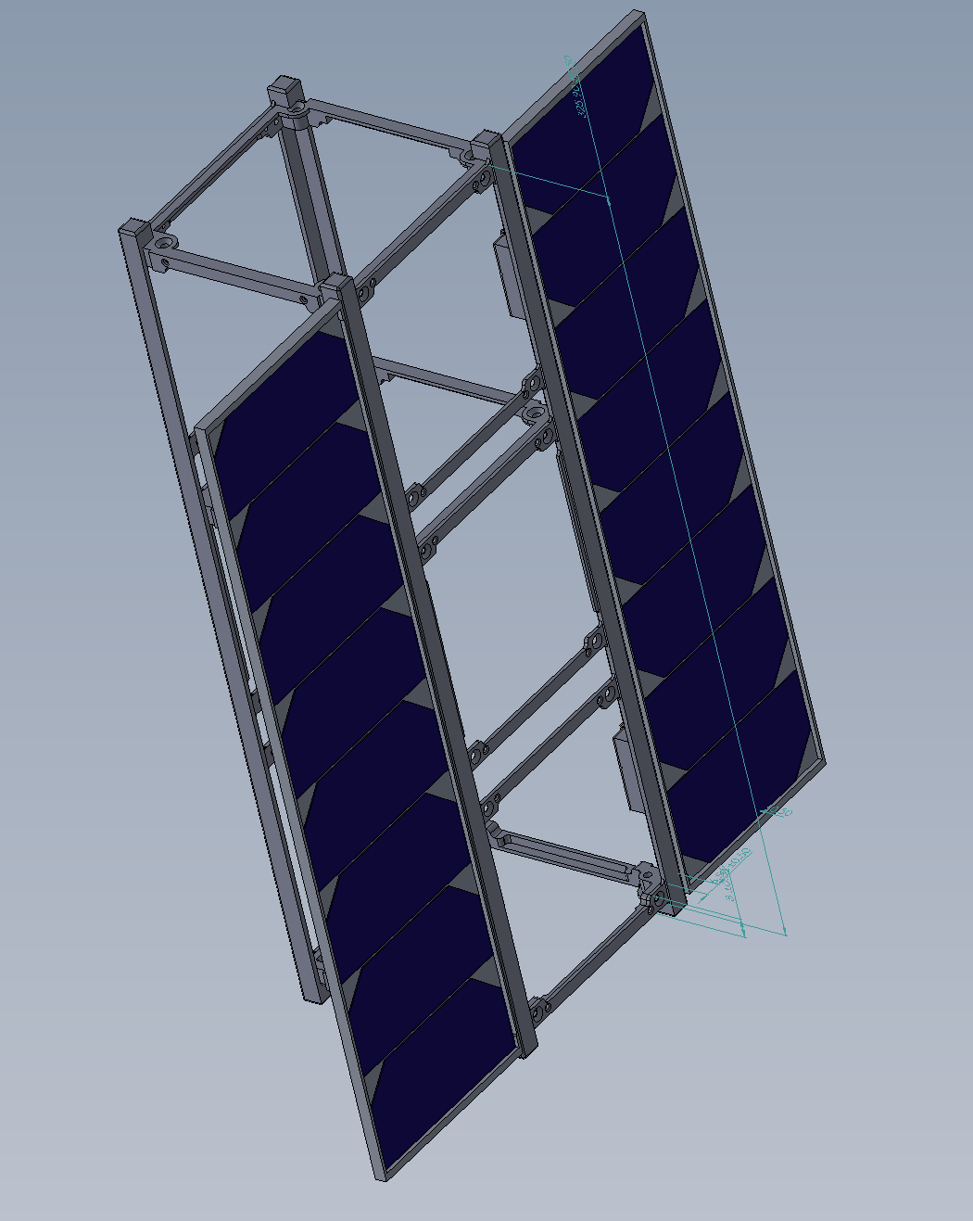

Array C

Array B

Array A

Figure – CAD model of satellite deployable solar panels

# Design Specifications:

## Electrical:

### Array A and C

1. Mounting pads for 8 solar cells
   1. Solar Cell: AzurSpace Quadruple Junction GaAs Solar Cell Type: QJ Solar Cell 4G32C - Advanced
2. 8 solar cells in series configuration (one output connection)

### Array B

1. Mounting pads for 2 solar cells
   1. Solar Cell: AzurSpace Quadruple Junction GaAs Solar Cell Type: QJ Solar Cell 4G32C - Advanced
2. 2 solar cells in isolated configuration (two output connections)
3. Mounting and pads for magnetorquer (TBD from ACDS)

### All Cells

1. Trace width must be large enough to take max current of ISC = 457.6 mA (+20% for safety buffer)
2. 2 Layer PCB (front and back)

## Mechanical:

1. Max dimension of PCB 325.7mm X 82.5mm.
   1. Refer to old PCB design (Github, previous PCBs repository)
2. Thermal management for magnetorquer and solar cells required
   1. Large Copper pad under solar cells (GND plate)
3. Mountings are to be integrated for mounting PCB on chassis and any other parts that require it.

# Left to be Answered:

|  |  |
| --- | --- |
| Requirement in Question | Action Item to Solve |
| What is the component footprint of the Solar cells? | Contact Manufacturer and refer to datasheet to determine |
| Do we have to integrate magnetorquers into PCB design? | To be determined by ACDS team. |
| If magnetorquers are be used, what is the component footprint? | Talk to ACDS Team or contact Manufacturer |

# What to do to Complete Project:

1. Obtain datasheets of respective parts
   1. Solar Cell: AzurSpace Quadruple Junction GaAs Solar Cell Type: QJ Solar Cell 4G32C - Advanced
   2. HIROSE DP12-5P-1.25DSA(50) connectors (respective pins and mating connector)
      1. Same connector as on EPS
   3. If confirmed, magnetorquer (Talk to Eric)
2. Obtain KiCAD competency on:
   1. Making part libraries (storing made components)
   2. Component Editor (make schematic component for part)
   3. Footprint Editor (make physical copper pad footprint for part)
   4. Schematic Editor (design electrical schematic)
   5. PCB Layout Editor (design PCB)
3. Begin design of Array A, B, and C based on specifications above.

# Important Notes:

* Use Github (Power Systems repository) to store completed or in progress work. Avoid using Slack too send key files that others can use. Likely will get lost in active chats.
  + Note: Properly organize files on Github so we don’t have a mess! Use folders with good names!
* Any new and better ideas should be brought up to the team, such as cost reductions, design changes, better parts, additions etc.
* For clarifications, just ask!!
* Everything in this document is subject to change.